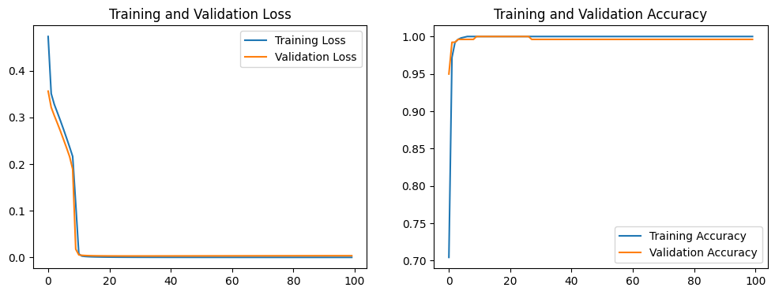

A

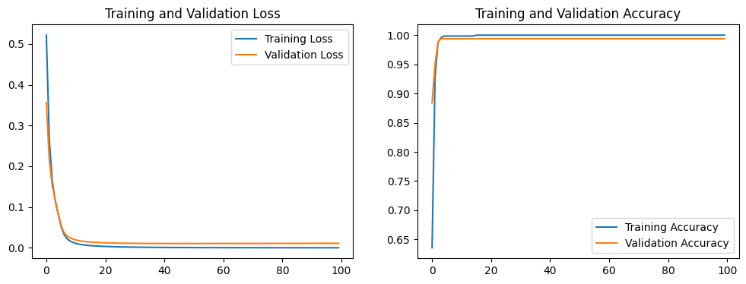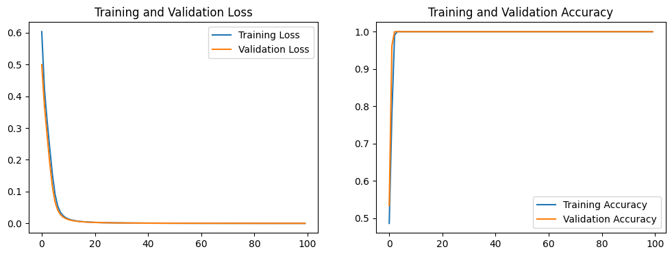

C

B

**Supplementary Figure 5:** The learning plots for the ANN classifier developed for (A) transcriptomics CRC data (B) DNA methylation CRC data (450k), and (C) DNA methylation CRC data (27k).

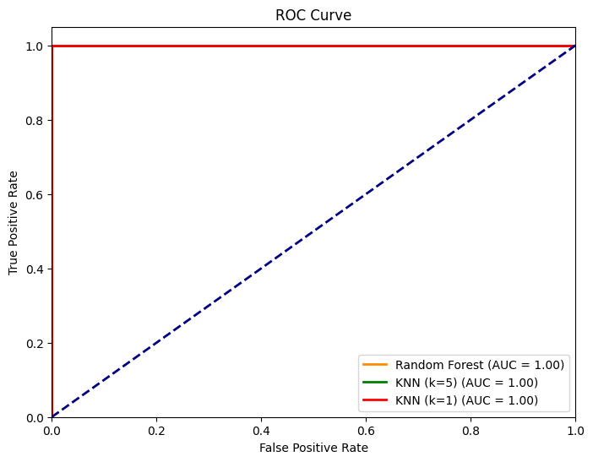

**Supplementary Figure 6:** ROC (Receiver Operating Characteristic) curve graph obtained for evaluating the performance of all developed models including Random Forest and K-Nearest Neighbors (KNN) with *k value* = 1 and *k value* = 0.